# Part 3: Finish the Battleship game

Modify the battleship game from part 2 to use the Canvas API for the user interface and to apply the Battleship rules for announcing hits and sinkings.

If you haven’t already done part 2, you’ll need to do it first, unless it’s given to you as a starting point.

Prerequisites: Chapters 1 to 12, 16.

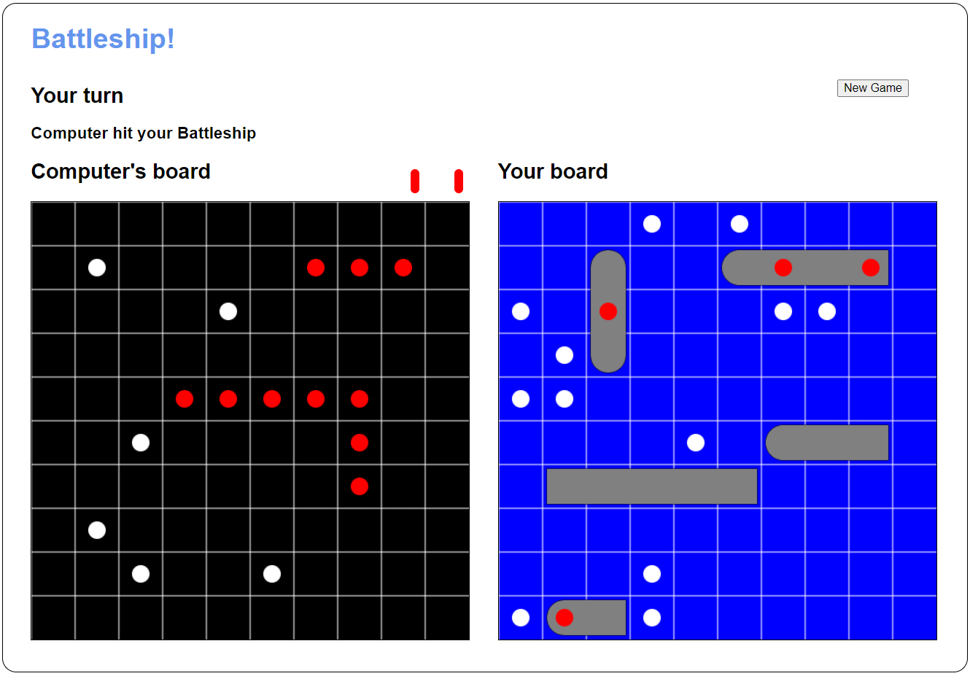

## Specifications

* Each game board should use a <canvas> element with a dark background and white gridlines. The computer’s board should have a black background and the user’s board should have a blue background.
* The ships should be drawn on the game board as shown above (the user’s ships display at the beginning of a game, while the computer’s ships display when the game is over).
* Hits should be drawn with red circles and misses with white circles.
* When there’s a hit, the app should announce what ship was hit and whether it was sunk.
* Each ship that’s sunk should be marked with a red peg above the game board. You can use another <canvas> element to do this, or you can add <span> elements that are styled with CSS (border and border-radius).